

Department of Computer Science

FACULTY OF COMPUTING AND ARTIFICIAL INTELLIGENCE

FYP SCOPE DOCUMENT PROCTR:
Intelligent Secure Lab Examination and Learning Management System with Behavioral Risk Analysis

Supervisor: Dr Sumaira Farid Manahil Ahmad 231557
Sumaiyyah Masood 231596

Shanawar Raza 231593

Supervisor Meeting Log:

Date | Discussion | Task Assignment | Supervisor Signature
Meeting 01  11 - 02 - 2026 | Discussed possible FYP ideas related to secure exam systems and AI- based monitoring. | Prepared and submitted the initial project proposal and basic system overview.
Meeting 02  27 - 02 - 2026 | Reviewed the initial proposal, clarified the project scope. | Revised proposal based on feedback and begin research on  technologies and existing systems.
Meeting 03  06 - 03 - 2026 | Initial Module discussion of the system. | Prepared a detailed module breakdown.
Meeting 04  09 - 03 - 2026 | Final discussion of the modules and confirmed proposal. | Finalized module list and prepared final proposal document.

Table of Contents
FACULTY OF COMPUTING AND ARTIFICIAL INTELLIGENCE 1
- Introduction 4
- Related System Analysis 5
- Problem Statement 6
- Problem Solution 6
  - Objectives 7
- Scope 7
- Modules 8
  - Authentication Module 8
  - Lab Network Validation and Communication Module 8
  - Exam Session Management 8
  - Exam Environment Control 9
  - Student Activity Tracking and Reporting 9
  - AI Cheating Detection Module 9
  - Live Monitoring Module 10
  - Crash Recovery and Resume Module 10
  - AI Exam Checking Module 10
  - Admin Control Module 10
  - System Configuration and Notification Module 11
- Data Gathering Approach 12
- Tools and Technologies 12
- Project Stakeholders and Roles 13
- Module-based Work Division 13
- Gantt Chart and Architecture Diagram 14
- Mockups 15
References 18

Introduction
Cheating in lab exams is a serious and growing problem in educational institutions. Teachers often cannot supervise many students at once, making it easy for students to cheat by accessing unauthorized websites, using applications like ChatGPT or Google, opening pre-existing files on the computer, or inserting USB drives during exams. Traditional camera-based monitoring is expensive, intrusive, and still cannot fully prevent these cheating methods.
To address this, we propose the PROCTR: Intelligent Secure Lab Examination System with Behavioral Risk Analysis, a desktop application installed on lab PCs. The system monitors the computer during exams, allowing only approved websites and applications, blocking and detecting USB drives and file access, also allows teachers to upload the exam paper directly to the system. Students can submit their solutions through the application, and an intelligent agent evaluates their work based on a rubric set by the teacher. The system analyzes behavior such as window switching, clipboard usage, and unusual activity patterns, generating risk reports that help instructors identify potential cheating.
This solution is privacy-friendly, deployable in real labs, and combines exam management, automated evaluation, and intelligent behavior monitoring to ensure fair, secure, and efficient assessments. It provides a scalable and practical approach that protects academic integrity while reducing the workload on teachers.

Related System Analysis
Several systems exist that aim to monitor or control exams, but most of them either rely heavily on cameras, are limited in scope, or do not provide automated evaluation. Below is a summary of some related systems and their weaknesses compared to our proposed solution:

Table 1. Related system analysis

Application Name | Weakness | Proposed Project Solution
Safe Exam Browser | Locks the browser but does not monitor student behavior at the OS level or detect suspicious patterns. | Our system monitors applications, processes, clipboard, network activity, and window switching, providing a detailed behavioral risk report for instructors.
Proctorio | Heavy reliance on continuous video/audio monitoring and complex setup; privacy concerns. | Our system avoids intrusive video/audio monitoring, focusing on intelligent agent- based behavior analysis.
Respondus LockDown Browser | Focuses only on browser lockdown and requires camera-based proctoring for cheating detection. | Our system is privacy-friendly, does not require constant webcam monitoring, and detects cheating using intelligent behavior analysis directly on the PC.
ExamSoft | Allows exam upload and submission, but lacks real- time behavioral monitoring and USB/file access control. | Our system combines exam upload, secure submission, and real-time monitoring of USBs, files, and application usage, ensuring both exam security and academic integrity.

Problem Statement
The lack of an intelligent, PC-based exam monitoring and evaluation system in universities and schools creates a significant challenge in maintaining academic integrity during lab exams. Traditional supervision methods, such as manual invigilation or camera-based proctoring, are often limited in effectiveness. Teachers cannot continuously monitor many students at once, leaving opportunities for cheating. Students can exploit these gaps by accessing unauthorized websites, using applications like ChatGPT or Google, opening existing files on the computer, or inserting USB drives to obtain answers.

Moreover, existing exam platforms typically allow teachers to upload exams and receive student submissions but do not provide real-time monitoring of student behavior or automated evaluation based on a teacher-defined rubric. This lack of integration makes it difficult to detect suspicious activities, evaluate answers efficiently, and ensure a fair and secure examination environment. There is a clear need for a comprehensive solution that combines exam management, intelligent behavior monitoring, and automated evaluation to protect academic integrity, reduce teacher workload, and provide a reliable assessment process for students.

Problem Solution
To address the challenges of cheating and inefficient exam management in lab exams, we propose a comprehensive Intelligent Secure Lab Examination System with Behavioral Risk Analysis. This desktop application will revolutionize the examination process by combining intelligent behavior monitoring, and automated evaluation. By controlling the student’s computer environment, the system blocks unauthorized software, restricts USB, and monitors activities such as window switching, clipboard usage, and application behavior.

Teachers can upload exam papers directly into the system, and students will submit their solutions through the application. An intelligent agent will analyze both the student’s behavior generating risk scores and reports for instructors. This integrated approach ensures fair and secure exams, reduces teacher workload, and provides actionable insights into potential cheating attempts. The system is privacy-friendly, deployable in real labs, and designed to scale for multiple students simultaneously, providing a practical and effective solution to modern security challenges.

Objectives
    - To develop a desktop application that provides a secure and intelligent lab examination system for educational institutions.
    - To prevent cheating during lab exams by controlling the student’s PC environment, including restricting unauthorized software, USBs, and file access.
    - To monitor student behavior in real-time, tracking activities such as window switching, clipboard usage, and application usage, and detecting suspicious patterns.
    - To enable teachers to upload exam papers and receive student submissions directly through the system, streamlining the exam process.
    - To implement an intelligent agent that evaluates student submissions based on a teacher- defined rubric, while also analyzing behavioral data to generate risk scores.
    - To provide instructors with comprehensive reports, dashboards, and live monitoring tools, helping them identify potential cheating without needing to supervise all students continuously.
    - To ensure privacy-friendly monitoring that avoids intrusive camera usage while maintaining academic integrity.
    - To create a scalable and deployable solution suitable for multiple students and labs, enhancing exam security, fairness, and efficiency.

Scope
The scope of this project is to design and develop a secure system for managing and monitoring lab examinations in educational institutions. The system will allow instructors to upload exam papers, define grading rubrics, and schedule lab examinations. During the exam, the system will create a controlled environment on lab computers and monitor student activity to detect suspicious behavior. Students will submit their answers through the system, and the submissions will be evaluated using test cases. Instructors will be able to review the results, verify grades, and generate reports containing exam performance and activity logs. The system aims to improve exam security while simplifying the management and evaluation of

lab examinations. Additionally, the system includes a web-based LMS portal that manages the complete examination workflow, including exam creation, approval, scheduling, invigilation assignment, and result visualization. This integration ensures centralized control and coordination among all stakeholders.

5.1 LMS-Based User Management System
To enhance the functionality of the proposed system, a web-based Learning Management System (LMS) portal will be integrated. This portal will provide role-based access to different stakeholders involved in the examination process. Each user will have specific permissions and responsibilities, ensuring a structured and secure workflow for exam management.

System Users and Roles
1. Students
- View lab exam schedules (date sheet)
- Receive notifications regarding exams
- Appear in exams through the desktop application
2. Faculty Member (Teacher) + Invigilator
- Create and upload exam papers
- Submit exams to the Head of Department (HOD) for approval
- Modify exams based on feedback
- Submit approved exams to the Exam Cell
- Start and manage exam sessions on the exam day
- Monitor exam progress using the system
3. Head of Department (HOD)
- Review submitted exam papers
- Approve exams
- Reject exams
- Provide feedback for improvement
Workflow:
- If approved or rejected → send back to faculty member
- If revisions needed → sent back to faculty member for resubmission
4. Departmental Exam Committee (DEC):
- Assign invigilators for lab exams
- Ensure invigilation coverage
- Handle replacement if assigned invigilator is unavailable
5. Coordinator:
- Create date sheets and exam schedules
- Assign lab rooms for exams
- Share schedules with students and invigilators

6. Exam Cell / Director Examination
- Access all exams and student results
- View analytical reports (graphs, charts, performance summaries)
- Ensure overall examination transparency and quality control

Modules

Authentication Module
Checks the identity of users before allowing them to access the system.

    - Login for Teacher, Student, and Admin
    - Check user credentials from the system database
    - Create a secure login session
    - Block unauthorized users

Lab Network Validation and Communication Module
Allows only computers from the selected lab network to join the exam.
    - Check if the IP belongs to the allowed lab range
    - Verify the correct subnet
    - Block devices outside the selected lab

Exam Session Management
Handles exam creation, distribution, timing, and submission.
    - Create exam session with session ID or password
    - Send exam paper to students
    - Start and end exams
    - Control exam timer for all students
    - Extend exam time when needed
    - Accept student submissions during the exam.
Submission Handling:
- Upload files to the teacher’s system
- Save files in student folder
- Block submissions after exam time end

Exam Environment Control
Restricts the student computer during the exam to reduce cheating.

    - USB detection
    - Prevent closing exam app
    - Browser control

Student Activity Tracking and Reporting
Records student actions during the exam.

    - Logs Application switching
    - Detects copy and paste actions
    - Logs USB insertion attempts
    - Logs website access attempts
    - Generate student activity records
    - Cheating probability analysis
    - Timeline of events

AI Cheating Detection Module
Analyzes student activity to estimate possible cheating.

Inputs Analyzed

    - Activity logs from the monitoring system
    - Copy and paste attempts
    - USB insertion
    - Window switching
    - Cheating from previously existing files

Outputs

    - Cheating probability score
    - Suspicious activity indicators

Live Monitoring Module
Shows real-time exam status to the teacher.

    - Display student IDs and cheating probability scores
    - Show connection status
    - Show system alerts

Crash Recovery and Resume Module
Allows the exam to continue if the application or computer stops unexpectedly.

    - Detect application crash or computer shutdown
    - Save exam progress locally
    - Allow the student to continue the exam
    - Restore the timer and monitoring

AI Exam Checking Module
Evaluates student submissions automatically using test cases. Also, using a tool called Moss to detect plagiarism in code.

Admin Control Module
Allows system administrators to control system settings and records.

    - Add or update lab networks
    - View exam records
    - Update lab configuration

System Configuration and Notification Module
Stores system settings and sends alerts to users.

    - Store exam rules and time limits
    - Send alerts to teachers and students
    - Schedule automatic tasks such as exam start or end
    - Provide system settings for other modules

User Access:

    - Admin: Change system settings
    - Teacher: View settings and receive alerts
    - Student: Receive alerts only

LMS Portal Module
- Role-based login system
- Dashboard for each user type
- Manage workflows between users

Exam Approval Workflow Module
- Submit exam to HOD
- Approve / Reject / Feedback system
- Track approval status

Scheduling and Date Sheet Module
- Create date sheets
- Assign labs and timings
- Notify students and invigilators

Invigilation Management Module
- Assign invigilators (DEC)
- Track invigilator availability

Result Visualization Module
- Generate charts and graphs
- Show performance analytics
- Provide reports for Director Exam

System Limitations

- The system cannot completely prevent all forms of cheating that occur outside the monitored PC environment, such as students sharing answers verbally or using devices not connected to the lab network.

- While the system monitors behavior using fuzzy logic, it may flag false positives or miss subtle cheating attempts, since it relies on predefined rules rather than continuously learning patterns.

- External factors, such as unanticipated software conflicts or lab configuration issues, can affect application performance and exam security.

- This system has been designed only for coding based exam. Subjects for example that require virtual machines are out of scope

Data Gathering Approach
Since our system uses fuzzy logic for analyzing student behavior and an test cases for checking, it does not require a large dataset for training. The fuzzy logic module estimates cheating probabilities based on predefined rules and thresholds, such as application switching, copy-paste attempts, and USB access, while data from controlled mock exam sessions is recorded to validate and fine-tune these rules.

Tools and Technologies
Table 2. Team Member Work Division for Proposed Project

Tools And Technologies | Tools | Rationale
Tools And Technologies | React.js | Frontend Development
Tools And Technologies | Python (Fast API) + Python pyQt | Backend Development
Tools And Technologies | Web Sockets and REST API | LAN Communication
Tools And Technologies | Skfuzzy | Fuzzy logic for cheating detection
Tools And Technologies | Test Cases/Moss | AI Exam Checking
Tools And Technologies | SHA256 Hashing | File Security
Tools And Technologies | Firebase/Neon storage | Database

Project Stakeholders and Roles
Table 3. Team Member Work Division for Proposed Project

Project Sponsor | Air University Islamabad
Stakeholder | - Manahil Ahmad  - Sumaiyyah Masood  - Shanawar Raza  - Dr Sumaira Fareed (Supervisor)  - Final Year Project Committee: Evaluation of project

Module-based Work Division
Table 4 . Member Work Division for Proposed Project

Student Name | Student Registration Number | Responsibility/ Module / Feature
Manahil Ahmad | 21557 | AI + Frontend + Monitoring  - AI Cheating Detection Module  - Activity Logging Module (monitoring part)  - Exam Control Module (frontend + logic)  - Live Monitoring Module
Shanawar Raza | 231593 | Backend + Security + AI Integration  - Desktop App  - Admin Control Module  - System Configuration and Notification Module

 |  | - Crash Recovery and Resume Module
Sumaiyyah Masood | 231596 | Test Cases + Backend + Full-Stack  - Lab Network Validation Module  - Report Generation Module  - Environment Control Module (backend  + monitoring)  - Authentication Module

Gantt Chart and Architecture Diagram

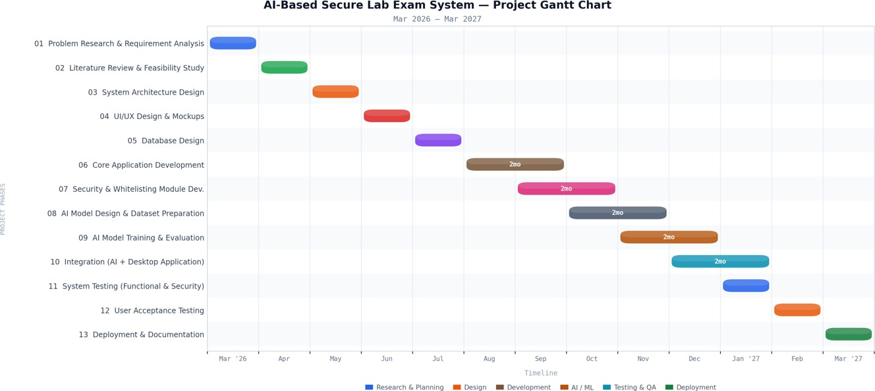
Figure 1. Gantt chart

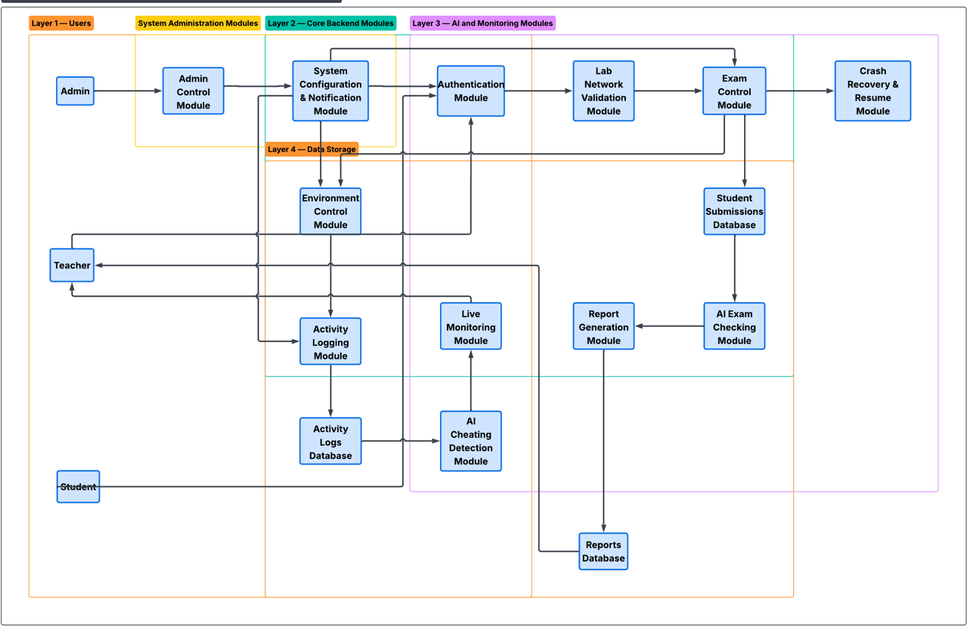
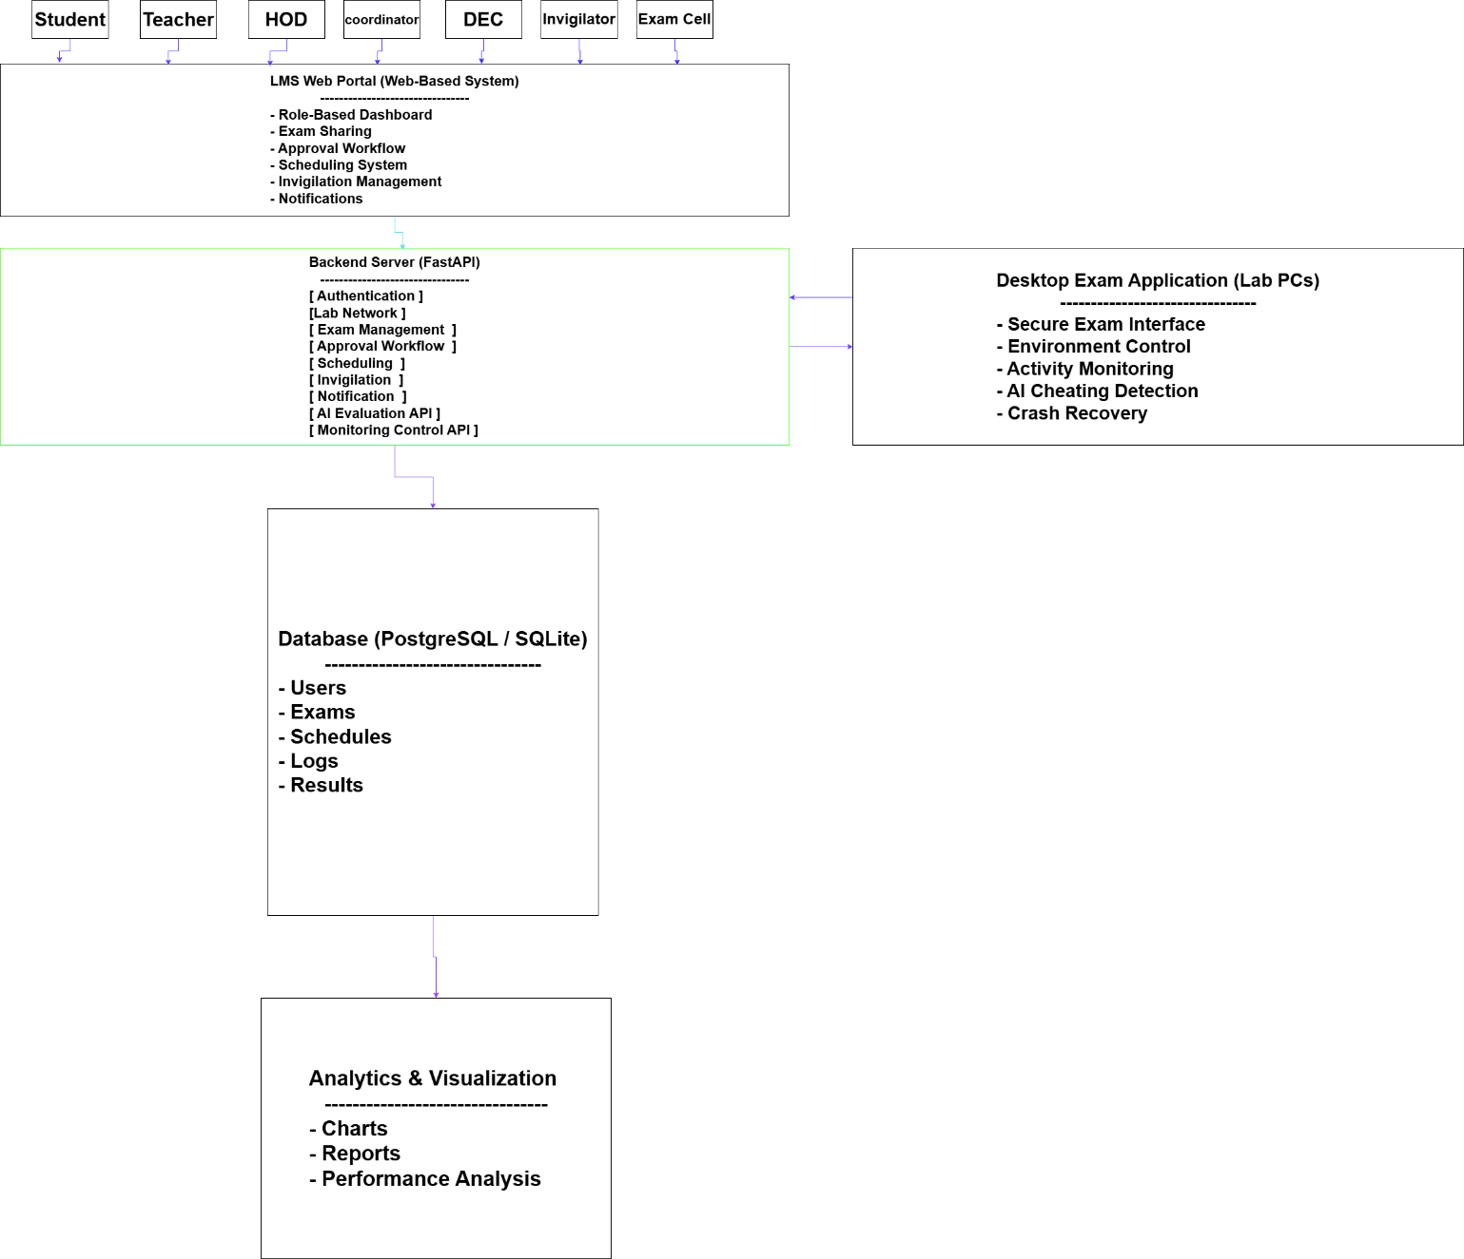
Figure 2. Architecture Diagram

Mockups
Log In
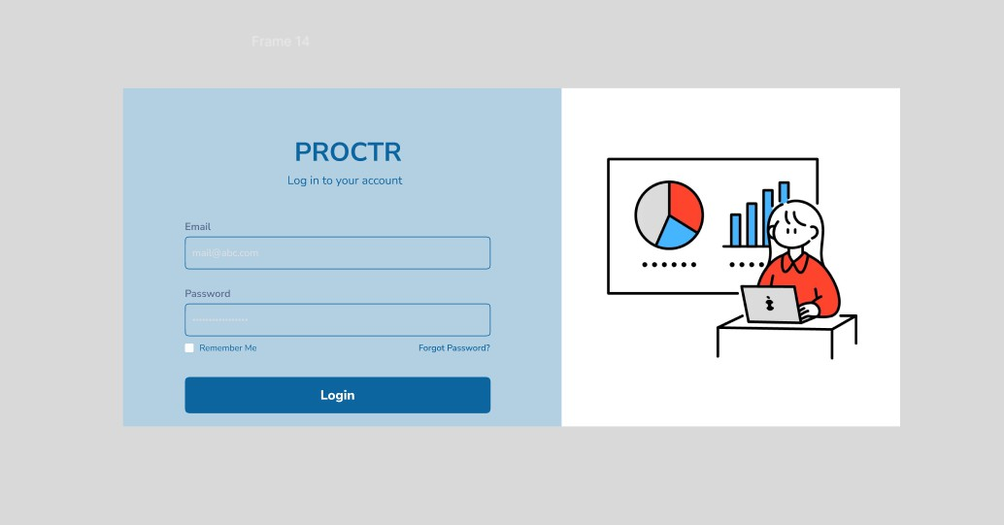
Figure 1. Log in page

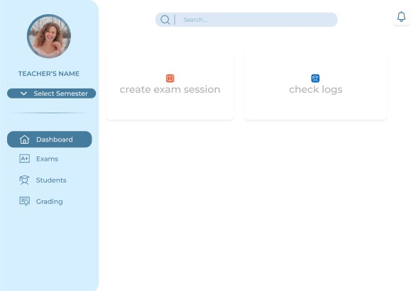
Figure 2. Dashboard

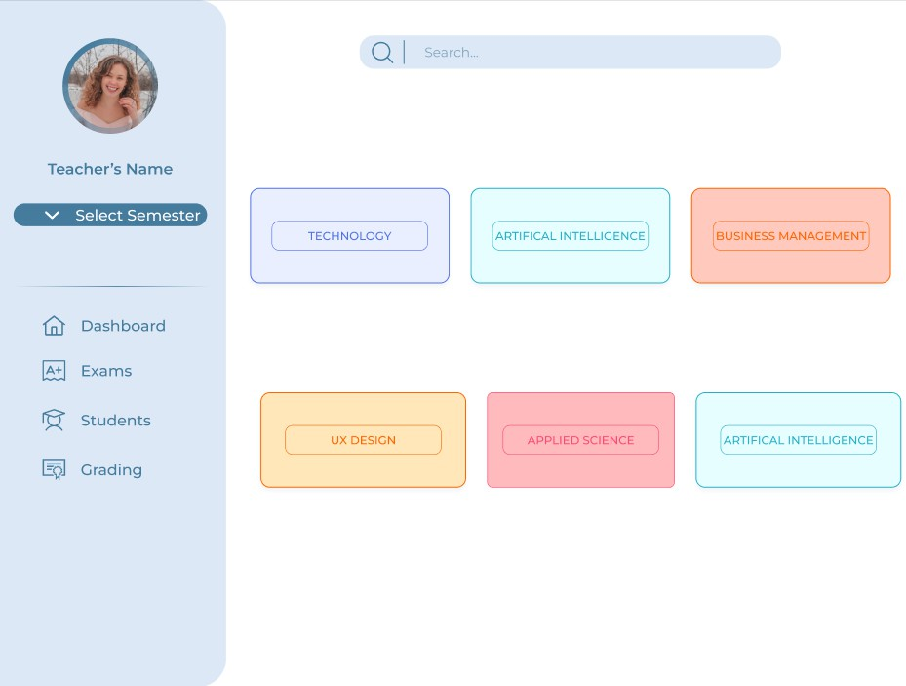
Figure 3. Dashboard Exams

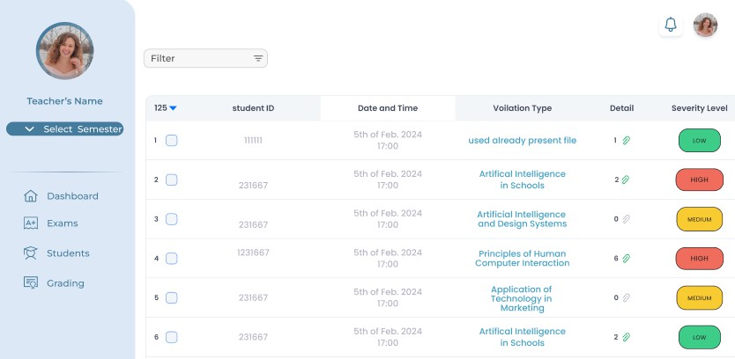
Figure 4. Dashboard Logs History

References
- Gusenga, D., Sumbiri, D., Ngugi, J., & Habimana, P. Design and Implementation of an E-Exam Cheating Control System Using Real-Time Monitoring and Behavioral Detection. Journal of Information and Technology, 5(9), 12-27, https://edinburgjournals.org/journals/index.php/journal-of-information- technolog/article/view/610
- Malekar, O., Karale, A., Pawara, P., & Gharat, R.
Real-Time Exam Monitoring. International Journal of Advanced Research in Science, Communication and Technology (IJARSCT),

- Esmat, M., Atta, A., & El-Said, W.K. Real Time Online Exam Monitor Management System in Educational Institutions. Journal of Information Systems Engineering and Management. https://jisem-journal.com/index.php/journal/article/view/11354

